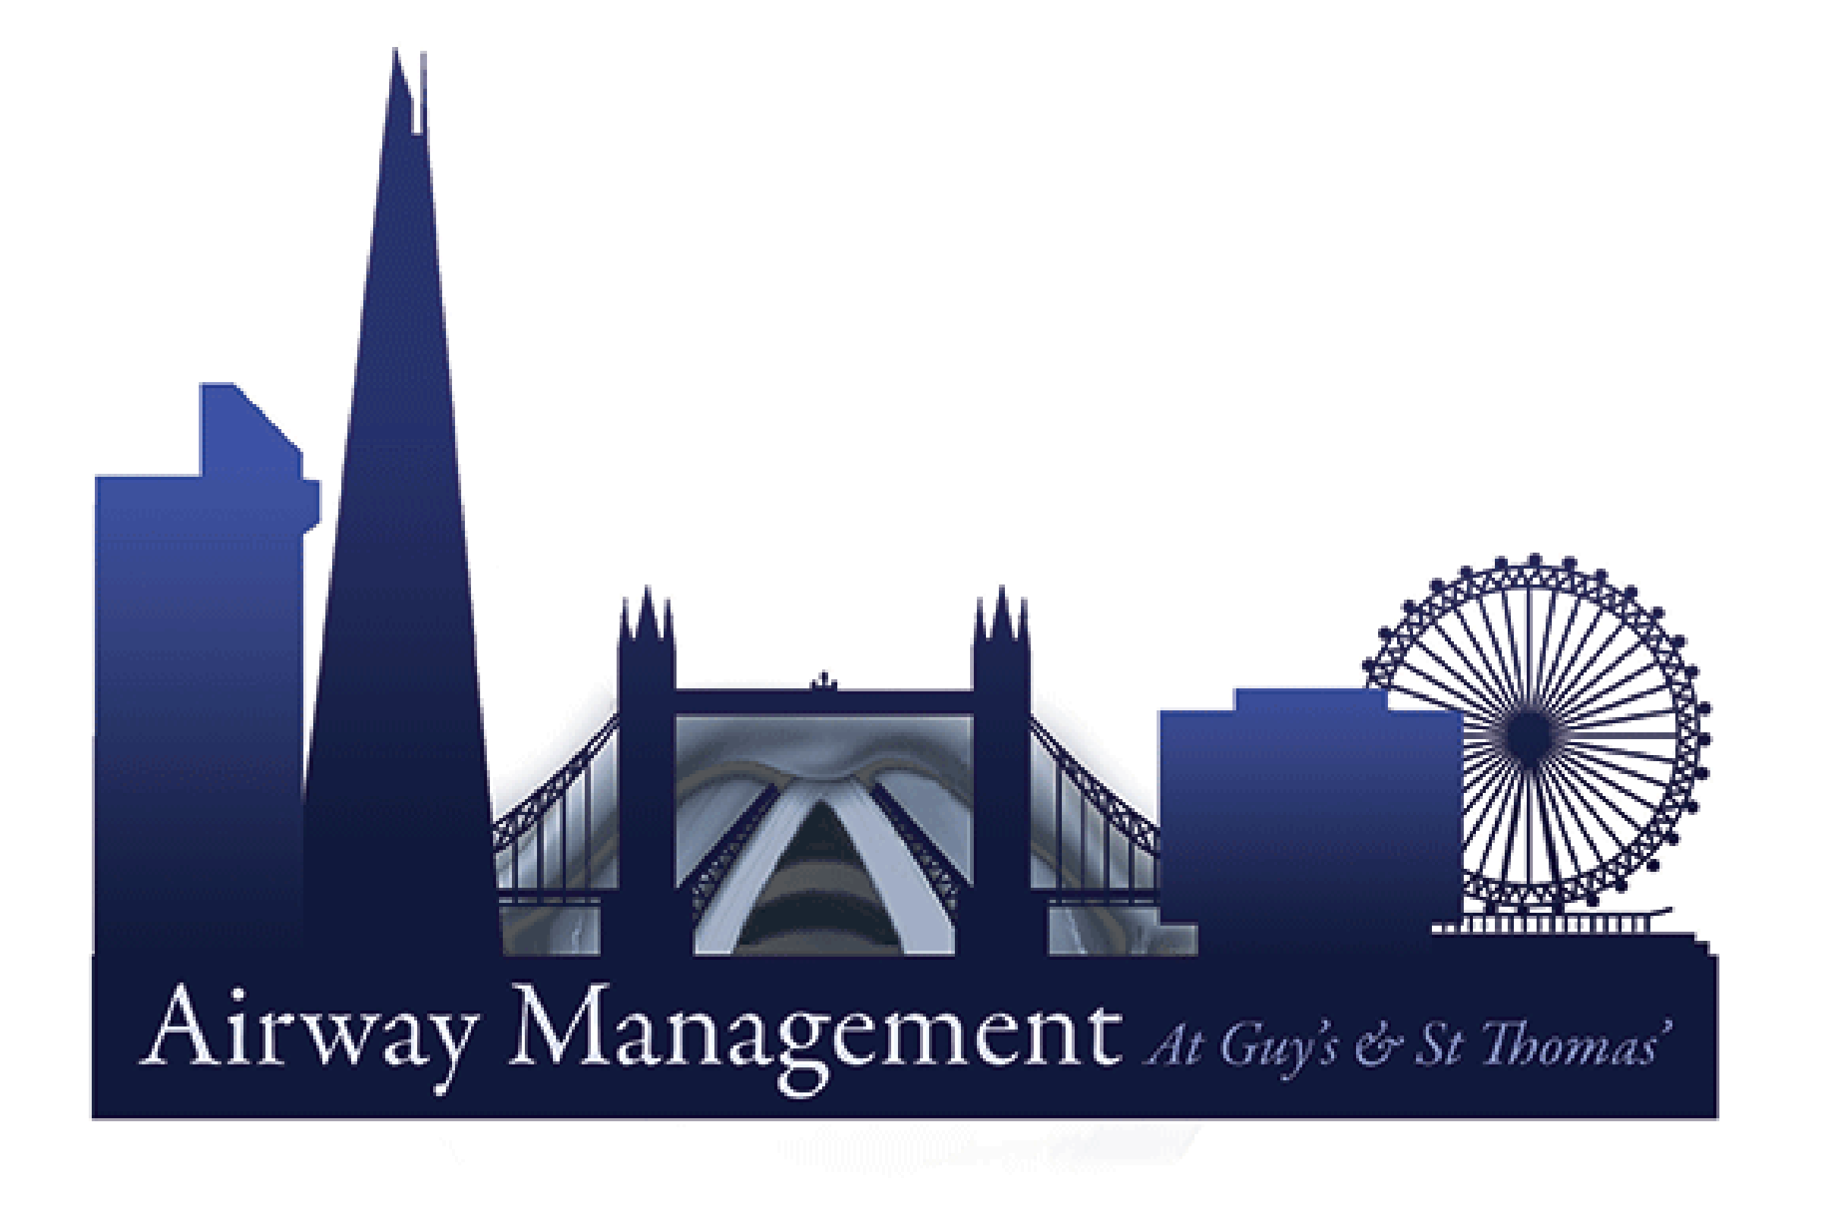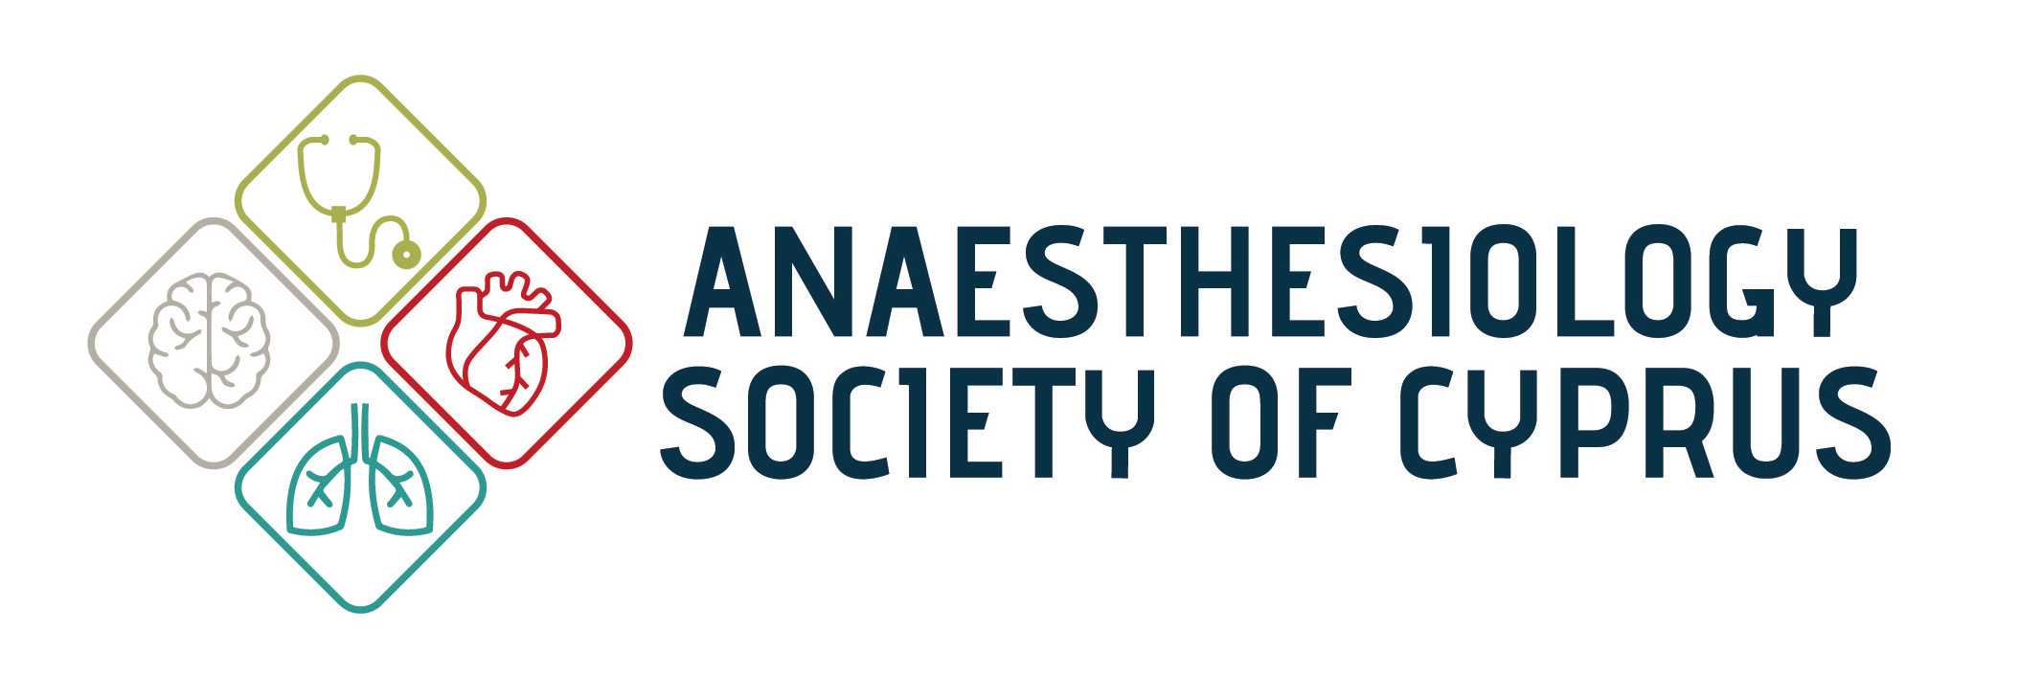

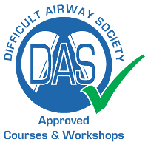

Mediterranean Advanced Airway Management Course, 12th May 2018

Dear Colleague

The Guy’s Advanced Airway Management Course (GAMC) has now successfully run it’s 12th course in central London. Now for the first time, the GAMC has joined forces with the Anaesthesiology Society of Cyprus to run the first Mediterranean Advanced Airway Management Course in Cyprus on the 12th May 2018.

The course will comprise a morning of talks and debates by internationally renowned airway experts including Dr Imran Ahmad, who is the course director for the GAMC course in London as well as being author for Difficult Airway Society (DAS UK) guidelines and lead for Airway Management at Guy’s Hospital in London. Other distinguished speakers are Dr Anil Patel, current DAS president, Dr Jairaj Rangasami, ex-DAS president and Dr Gunjeet Dua, organizer of the DAS UK airway workshops 2018 in London.

The afternoon will comprise of DAS approved workshops in Advanced Airway Management as detailed below to include the exciting new advance in 3D Airway reconstruction, Virtual Endoscopy; a software available for free for all anaesthetists to get training in and use.

General Course Information:

Seminar and Workshop Language: English

Workshops:
Awake fibreoptic intubation skills
Intubation via supraglottic airways
ORSIM
Video laryngoscopy
Front of neck access
Paediatric airway
Virtual endoscopy

Venue:
European University Cyprus (6 Diogenous str., Engomi, 2404 Nicosia, www.euc.ac.cy)

Fees:

Full course: (includes morning lectures, afternoon workshops, coffee breaks, light lunch, gala dinner):
200€ for consultants 150€ for active members of Anaesthesiology Society of Cyprus
75€ for trainees

Lectures only (morning) :
50€ for non-members of the Anaesthesiology Society of Cyprus
30€ for active members

Registration:
Please complete and send the registration form (attached) via email to gamc.cyprus@gmail.com. We can only confirm a place on the course upon receipt of payment by:
- Cheque payable to the 'Anaesthesiology Society of Cyprus' (14 Thasou str., RITA COURT 17, 1087 Nicosia)
OR

- Bank transfer ( IBAN : CY89 0020 0111 0000 0001 0295 1600 , Bank of Cyprus )

Accommodation:
Special rates for MAAMC course attendees at the Classic Hotel, Nicosia (94 Rigenis str. 1513, Nicosia, tel. Num. +357 22 664006, booking email: reservations@classic.com.cy). Please inform the hotel about your participation to the course in order to receive your special rate. Reservation will be upon availability.

Cyprus is a well known island to take a holiday enjoying the Mediterranean Sea and sun. We invite you to take some time and enjoy the weather and sites of our country.

For further information and assistance, email to gamc.cyprus@gmail.com

We look forward to welcoming you to our course and Cyprus.

Best Wishes

Guy’s Advanced Airway Management Course and the Anaesthesiology Society of Cyprus
gamc.cyprus@gmail.com

